**DATA ANALYTICS WITH TABLEAU**

**LONG-TERM INTERNSHIP**

**TEAM LEADER :** BHANUPRAKASH SINGAMPALLI

**TEAM MEMBERS :**1) THOMAS SEERAPU

2) SWAMY SETTI

3) S.K.S.R. KOUSHIK

4) GANESH SINGURU

**India’s Agricultural Crop Production Analysis(1197-2021)**

This report delves into the captivating realm of India's agricultural cultivation, providing a comprehensive visual exploration of key aspects and trends in the agricultural sector. Through the visual representations, readers can gain valuable insights into crop production, seasonal variations, regional distribution, and overall production trends. These visualizations enable intuitive analysis, allowing stakeholders to uncover patterns, identify areas of growth or concern, and make data-driven decisions.

By harnessing the power of Tableau, this report not only presents the data in a visually appealing manner but also provides an interactive experience for readers to explore the intricacies of India's agricultural cultivation. To Extract the Insights from the data and put the data in the form of visualizations, Dashboards and Story we employed Tableau tool.

**Technical Architecture:**

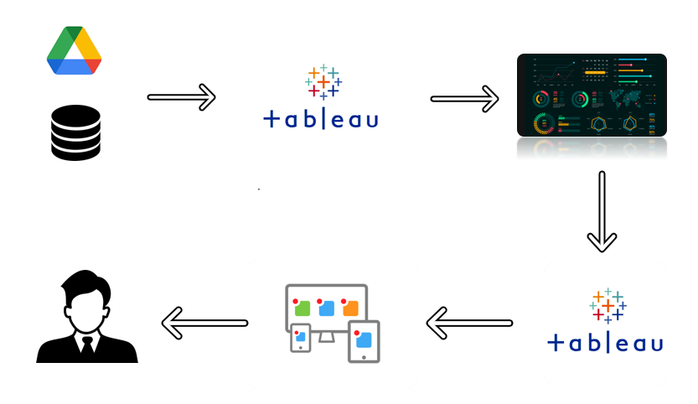

**Project Flow**

To accomplish this, we have to complete all the activities listed below,

* Define Problem / Problem Understanding
  + Specify the business problem
  + Business requirements
  + Literature Survey
  + Social or Business Impact.
* Data Collection & Extraction from Database
  + Collect the dataset,
  + Storing Data in DB
  + Perform SQL Operations
  + Connect DB with Tableau
* Data Preparation
  + Prepare the Data for Visualization
* Data Visualizations
  + No of Unique Visualizations
* Dashboard
  + Responsive and Design of Dashboard
* Story
  + No of Scenes of Story
* Performance Testing
  + Amount of Data Rendered to DB ‘
  + Utilization of Data Filters
  + No of Calculation Fields
  + No of Visualizations/ Graphs
* Web Integration
  + Dashboard and Story embed with UI With Flask
* Project Demonstration & Documentation
  + Record explanation Video for project end to end solution
  + Project Documentation-Step by step project development procedure

**Milestone 1: Define Problem / Problem Understanding**

**Activity 1: Specify the business problem**

This report delves into the captivating realm of India's agricultural cultivation, providing a comprehensive visual exploration of key aspects and trends in the agricultural sector. Through the visual representations, readers can gain valuable insights into crop production, seasonal variations, regional distribution, and overall production trends. These visualizations enable intuitive analysis, allowing stakeholders to uncover patterns, identify areas of growth or concern, and make data-driven decisions.

By harnessing the power of Tableau, this report not only presents the data in a visually appealing manner but also provides an interactive experience for readers to explore the intricacies of India's agricultural cultivation. To Extract the Insights from the data and put the data in the form of visualizations, Dashboards and Story we employed Tableau tool.

**Activity 2: Business requirements**

The primary business requirements for this report are to visualize and analyze business expenses, provide industry-specific insights, identify cost drivers, highlight outliers, and offer interactive functionality. Stakeholders need a visual representation of expenses to compare and analyze spending patterns across different businesses and industries. The report should facilitate the identification of key cost drivers, enabling stakeholders to understand the primary factors contributing to expenses. Additionally, it should flag any outliers or anomalies for further investigation. The report should provide a user-friendly and intuitive experience that empowers stakeholders to make data-driven decisions and drive positive change in the agricultural sector.

**Activity 3: Literature Survey**

The literature survey section of the report provides a concise overview of India's agricultural sector, focusing on key aspects and insights from existing studies and publications. It examines the historical context of agricultural practices in India and highlights the role of government policies and initiatives in supporting the sector's growth and development.

The survey explores the diversity of crops cultivated across different regions, along with trends in production and the impact of climate variability. It also addresses the adoption of technology and innovation in agriculture, along with the challenges faced by farmers and potential research gaps.

Additionally, the section showcases best practices and success stories that have contributed to improved productivity and sustainability in Indian agriculture. This literature review forms the basis for the subsequent analysis and visualization of agricultural data in the report.

**Activity 4: Social or Business Impact.**

Social Impact: On the social front, agriculture serves as a vital source of livelihood for a large portion of the population, especially in rural areas. It plays a crucial role in ensuring food security and alleviating poverty by providing employment opportunities and income generation. Moreover, agricultural activities contribute to the overall socio-economic development of rural communities, fostering social cohesion and preserving cultural traditions.

Business Impact: From a business perspective, the agricultural sector plays a pivotal role in India's economy. It contributes to the country's GDP and serves as a source of raw materials for various industries, such as food processing, textile, and pharmaceuticals. The growth and productivity of the agricultural sector have direct implications for the overall economic performance and stability of the nation. Furthermore, advancements in agricultural practices and technology have the potential to enhance productivity, optimize resource utilization, and promote sustainable practices. This, in turn, can lead to increased profitability and competitiveness for agricultural businesses.

**Milestone 2: Data Collection & Extraction from Database**

Data collection is the process of gathering and measuring information on variables of interest, in an established systematic fashion that enables one to answer stated research questions, test hypotheses, evaluate outcomes and generate insights from the data.

**Activity 1: Downloading the dataset**

https://docs.google.com/document/d/1s6OH0P9rNEmh6PJIYic8Wwja4PZ-xdKv/edit?usp=sharing&ouid=114172612492471861646&rtpof=true&sd=true

**Activity 1.1: Understand the data**

Data consists of 345409 rows and 10 columns that correspond to different values.

**Column Description of the Dataset:**

State : The name of the Indian states.

District : The name of the districts of Indian states.

Crop : Name of different crops grown in India

Year : Date

Season : India has 5 seasons for crop cultivation kharif, rabi, autumn, winter and summer.

Area: Area for crop cultivation in acres

Production : Production of crops in tonnes

Yield : Yield by the crops under cultivation

**Activity 2: Storing Data in DB & Perform SQL Operations**

Storing data in a database and performing SQL operations involves several steps. Here's a general guide:

1. **Choose a Database Management System (DBMS)**: There are various DBMS options like MySQL, PostgreSQL, SQLite, MongoDB, etc. Choose one based on your requirements such as scalability, data structure, ACID compliance, etc.
2. **Design Your Database Schema**: Plan out the structure of your database by defining tables, their columns, data types, relationships, constraints, etc. This is usually done using a schema definition language or a graphical interface provided by the DBMS.
3. **Connect to the Database**: Use the appropriate programming language or tool to establish a connection to your database. Most DBMSs provide libraries or drivers for popular programming languages like Python, Java, C#, etc.
4. **Perform CRUD Operations**:
   1. **Create**: Insert new records into the database using the **INSERT** statement.
   2. **Read**: Retrieve data from the database using the **SELECT** statement.
   3. **Update**: Modify existing records in the database using the **UPDATE** statement.
   4. **Delete**: Remove records from the database using the **DELETE** statement.
5. **Handle Transactions**: If your application involves multiple database operations that need to be executed as a single unit, you can use transactions to ensure data integrity. Begin a transaction, execute your operations, and then commit or rollback the transaction based on the outcome.
6. **Handle Errors**: Implement error handling mechanisms to deal with issues like connection failures, query errors, etc. This ensures graceful handling of errors and prevents unexpected behavior.
7. import sqlite3
8. # Connect to SQLite database
9. conn = sqlite3.connect('example.db')
10. cursor = conn.cursor()
11. # Create table
12. cursor.execute('''CREATE TABLE IF NOT EXISTS users
13. (id INTEGER PRIMARY KEY, name TEXT, email TEXT)''')
14. # Insert data
15. cursor.execute("INSERT INTO users (name, email) VALUES (?, ?)", ('John Doe', 'john@example.com'))
16. # Read data
17. cursor.execute("SELECT * FROM users")
18. rows = cursor.fetchall()
19. for row in rows:
20. print(row)
21. # Update data
22. cursor.execute("UPDATE users SET email = ? WHERE name = ?", ('john_doe@example.com', 'John Doe'))
23. # Delete data
24. cursor.execute("DELETE FROM users WHERE name = ?", ('John Doe',))
25. # Commit changes and close connection
26. conn.commit()
27. conn.close()

**Activity 3: Connect DB with Tableau**

Connecting a database with Tableau is relatively straightforward. Here's a general guide on how to do it:

1. **Launch Tableau Desktop**: Start by opening Tableau Desktop, the software used for data visualization and analytics.
2. **Connect to Data**: In Tableau Desktop, you'll see a "Connect" pane on the left side. Click on it to open various data connection options.
3. **Select Database**: Choose the appropriate database option based on the DBMS you're using. Tableau supports a wide range of databases including MySQL, PostgreSQL, SQL Server, Oracle, etc. If you're using a cloud-based service like Amazon Redshift or Google BigQuery, you can find connectors for those as well.
4. **Provide Connection Details**: Tableau will prompt you to enter connection details such as server name, database name, authentication method (username/password or integrated security), port number, etc. Enter these details accurately.
5. **Connect to Specific Tables or Write Custom SQL**: After establishing the connection, you can select specific tables/views from the database to work with. You can also write custom SQL queries directly within Tableau if you need to perform more complex operations or join multiple tables.
6. **Data Preparation and Visualization**: Once connected, Tableau will load the data from the database. You can then perform data preparation tasks like filtering, sorting, grouping, and calculations directly within Tableau's interface. Finally, you can create visualizations like charts, graphs, maps, etc., based on your data analysis requirements.
7. **Save and Publish**: After creating your visualizations, you can save your Tableau workbook and publish it to Tableau Server or Tableau Online to share it with others in your organization or embed it into web pages.

Keep in mind that the exact steps may vary slightly depending on the version of Tableau you're using and the specific database you're connecting to. However, the general process remains consistent across different setups.

**Milestone 3: Data Preparation**

**Activity 1: Prepare the Data for Visualization**

Preparing the data for visualization involves cleaning the data to remove irrelevant or missing data, transforming the data into a format that can be easily visualized, exploring the data to identify patterns and trends, filtering the data to focus on specific subsets of data, preparing the data for visualization software, and ensuring the data is accurate and complete. This process helps to make the data easily understandable and ready for creating visualizations to gain insights into the performance and efficiency.

**Milestone 4: Data Visualization**

Data visualization is the process of creating graphical representations of data to help people understand and explore the information. The goal of data visualization is to make complex data sets more accessible, intuitive, and easier to interpret. By using visual elements such as charts, graphs, and maps, data visualizations can help people quickly identify patterns, trends, and outliers in the data.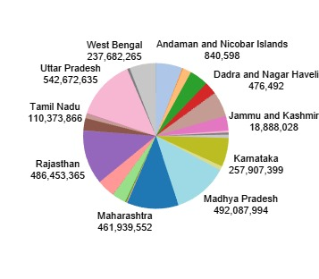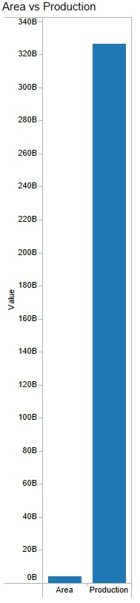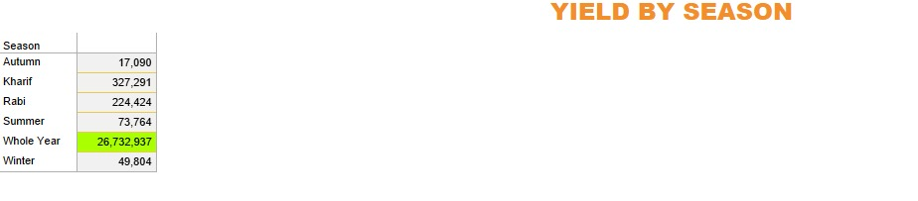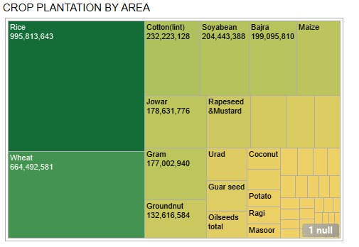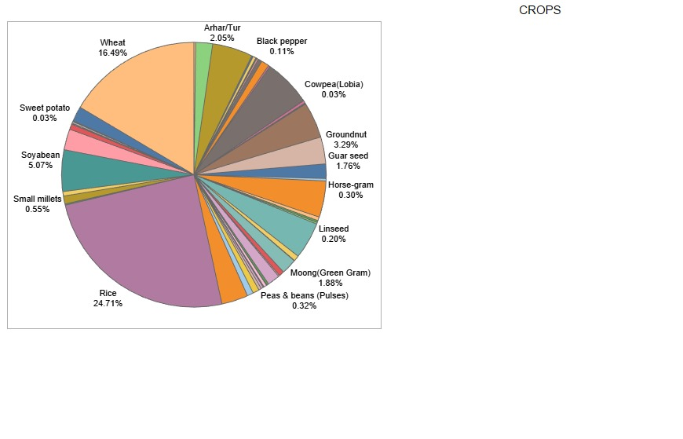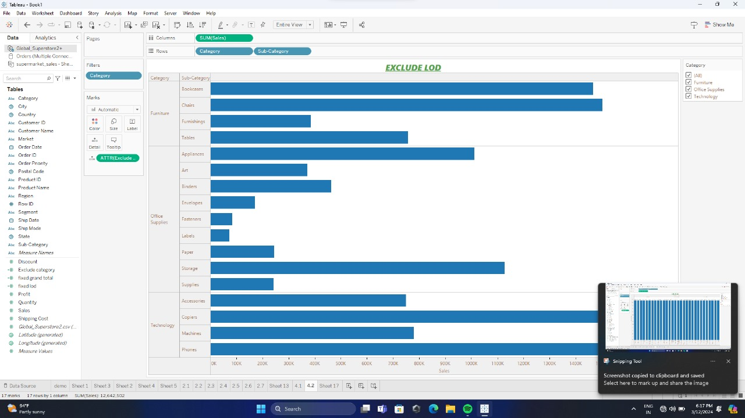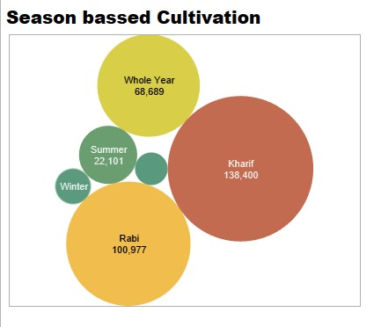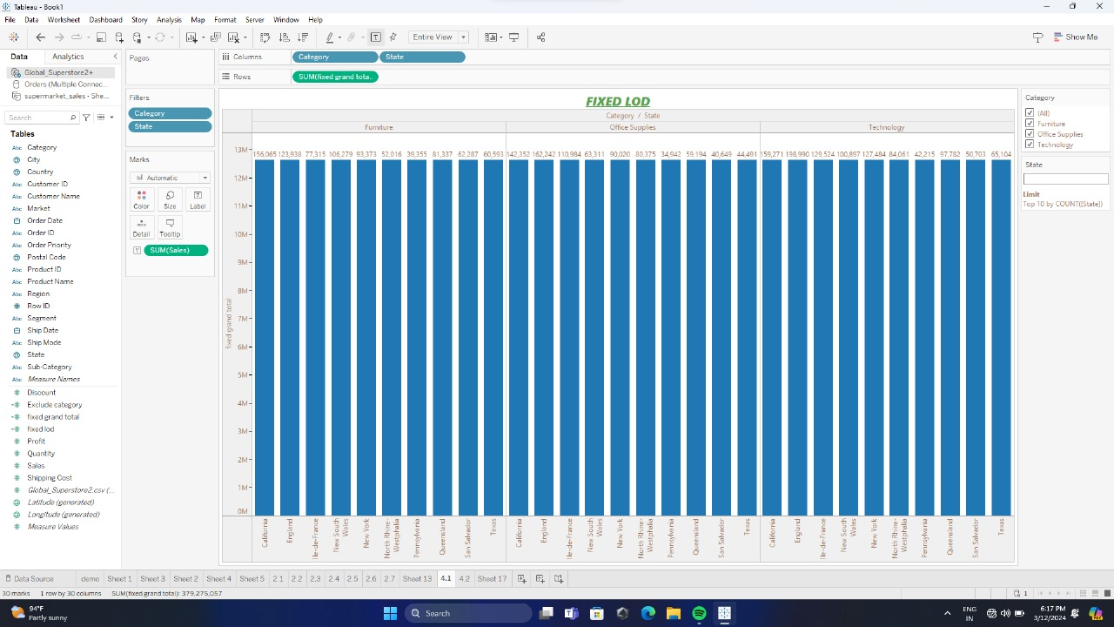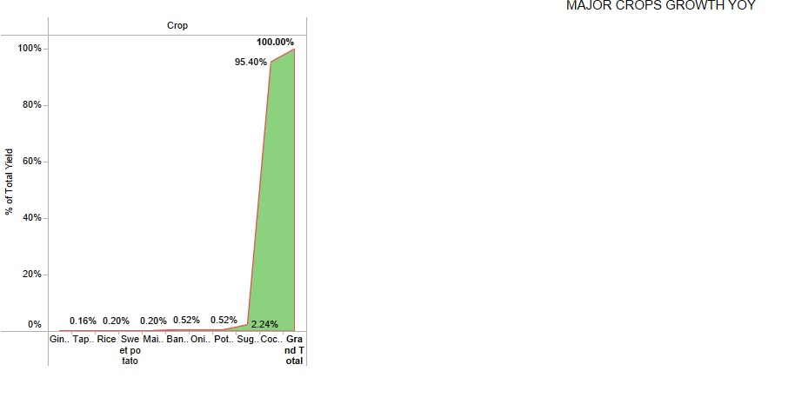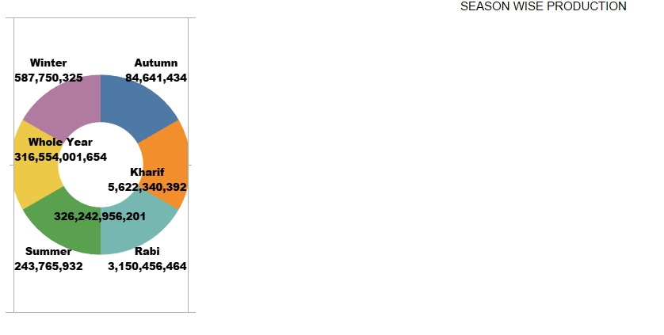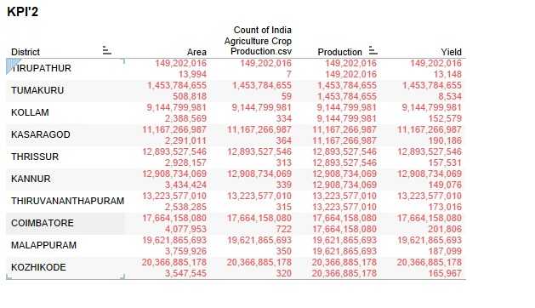

**Activity 1: No of Unique Visualizations**

The number of unique visualizations that can be created with a given dataset. Some common types of visualizations that can be used to analyse the performance and efficiency of banks include bar charts, line charts, heat maps, scatter plots, pie charts, Maps etc.

**Activity 1.1 : State wise Agricultural Land**

**Activity 1.2 : Area vs Production**

**Activity 1.3 : Season based cultivation**

**Activity 1.4 : Yield by season**

**Activity 1.5 : Crop plantation by area**

**Activity 1.6 : Major crops growth Yoy**

**Activity 1.7 : Crops**

**Activity 1.8 : Season wise production**

**Activity 1.9 : Kpi’s**

**Milestone 5: Dashboard**

A dashboard is a graphical user interface (GUI) that displays information and data in an organized, easy-to-read format. Dashboards are often used to provide real-time monitoring and analysis of data and are typically designed for a specific purpose or use case. Dashboards can be used in a variety of settings, such as business, finance, manufacturing, healthcare, and many other industries. They can be used to track key performance indicators (KPIs), monitor performance metrics, and display data in the form of charts, graphs, and tables.

**Activity 1: Responsive and Design of dashboard**

Once you have created views on different sheets in Tableau, you can pull them into a dashboard.

**Activity 1.1 : Dashboard 1**

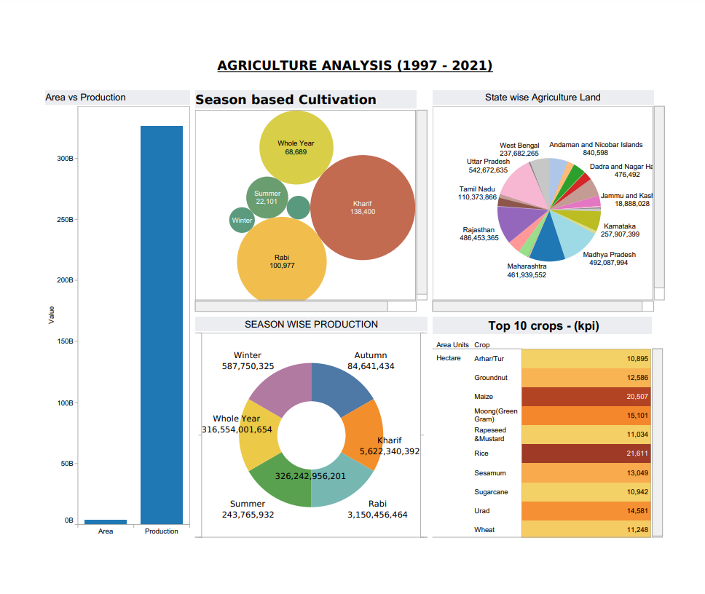

**Activity 1.2 : Dashboard 2**

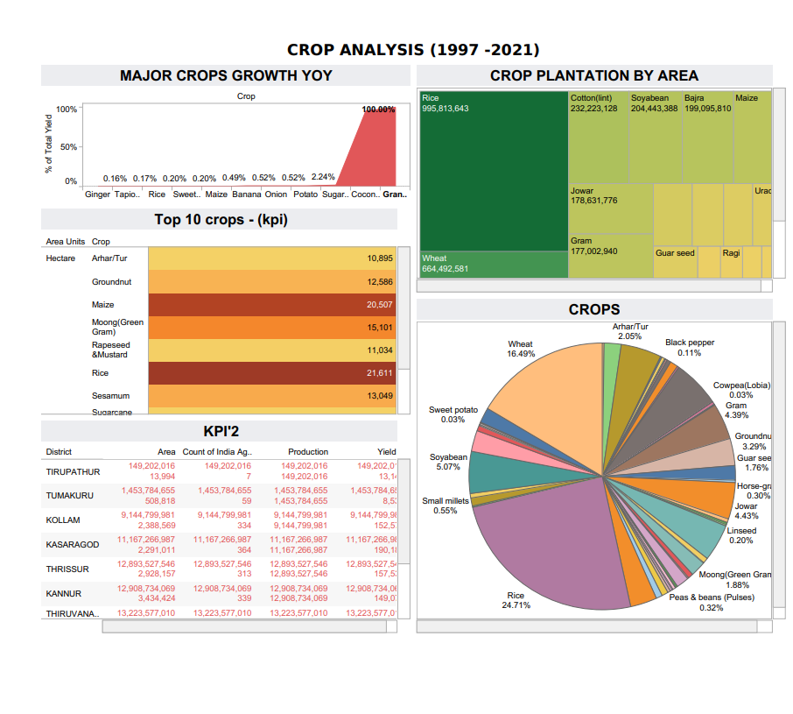

**Milestone 6: Story**

A data story is a way of presenting data and analysis in a narrative format, intending to make the information more engaging and easier to understand. A data story typically includes a clear introduction that sets the stage and explains the context for the data, a body that presents the data and analysis logically and systematically, and a conclusion that summarizes the key findings and highlights their implications. Data stories can be told using a variety of mediums, such as reports, presentations, interactive visualizations, and videos.

**Activity 1: Number of scenes in a story**

The number of scenes in a storyboard for a data visualization analysis of the performance of banks will depend on the complexity of the analysis and the specific insights that are trying to be conveyed. A storyboard is a visual representation of the data analysis process and it breaks down the analysis into a series of steps or scenes.

**Activity 1.1 : Story 1**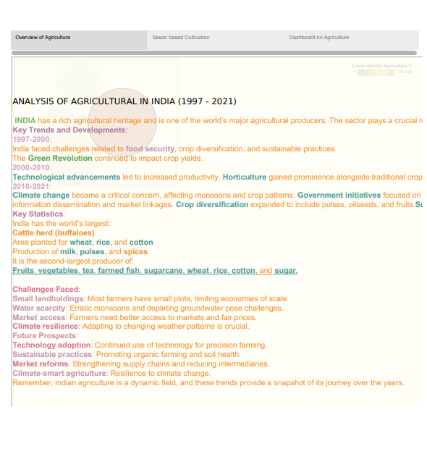

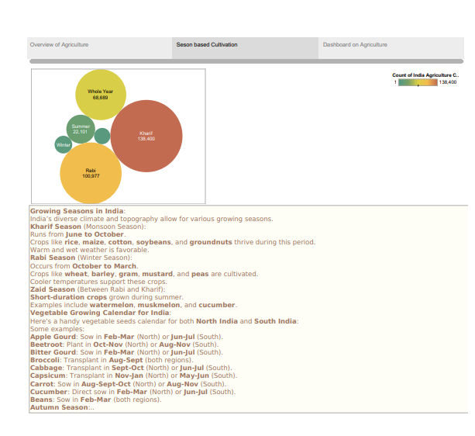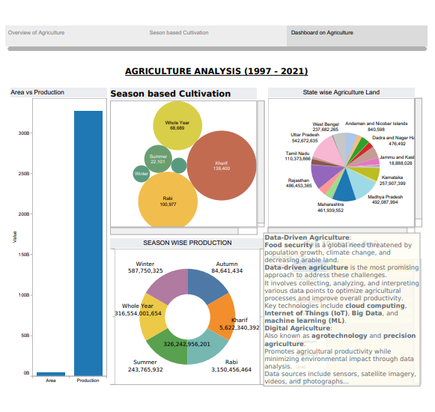

**Activity 1.1 : Story 2**

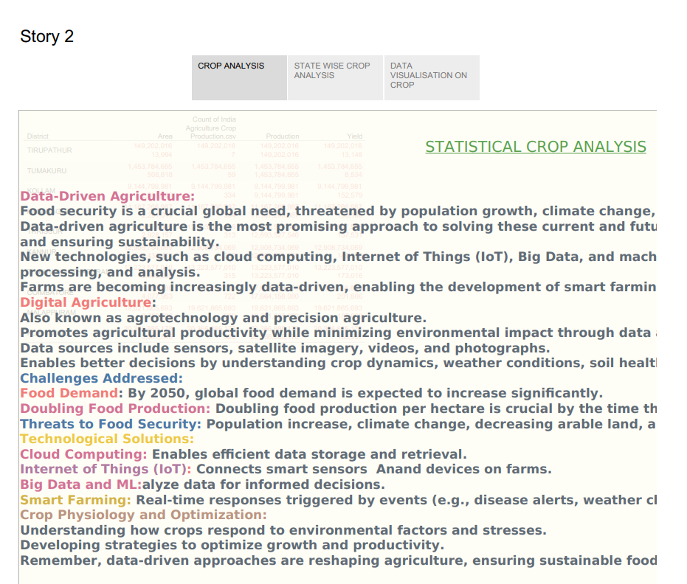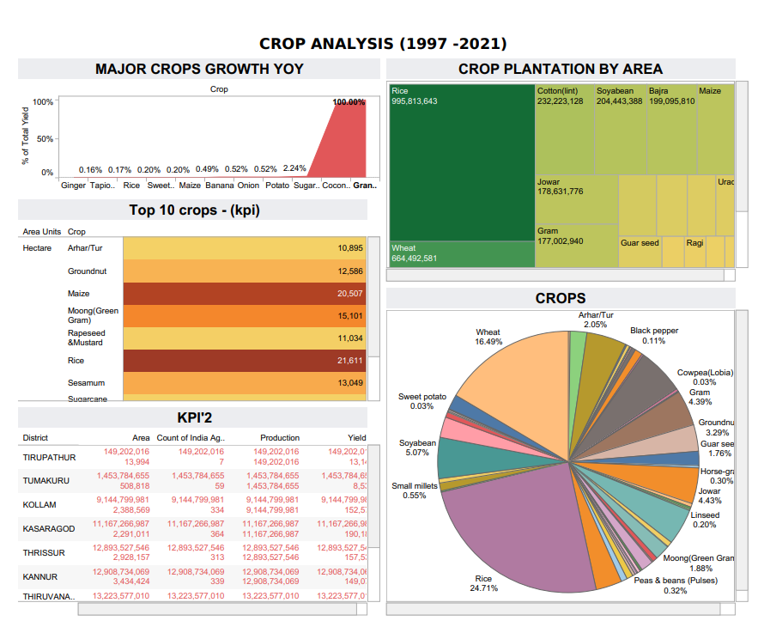

**Milestone 7: Performance Testing**

**Activity 1: Amount of Data Rendered to DB**

* The amount of data that is rendered to a database depends on the size of the dataset and the capacity of the database to store and retrieve data.
* Open the MySQL Workbench, go to the database then click to expand the tables,select the table and click on (i) button to get the information related to table such as column count,table rows etc.

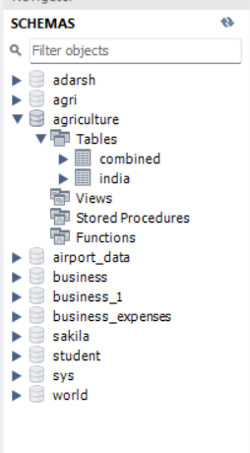

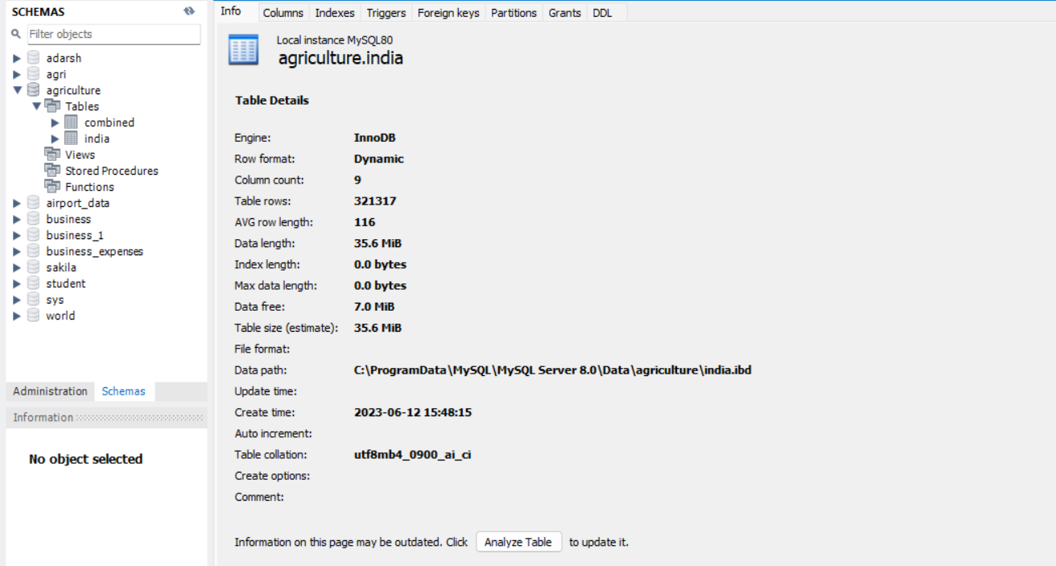

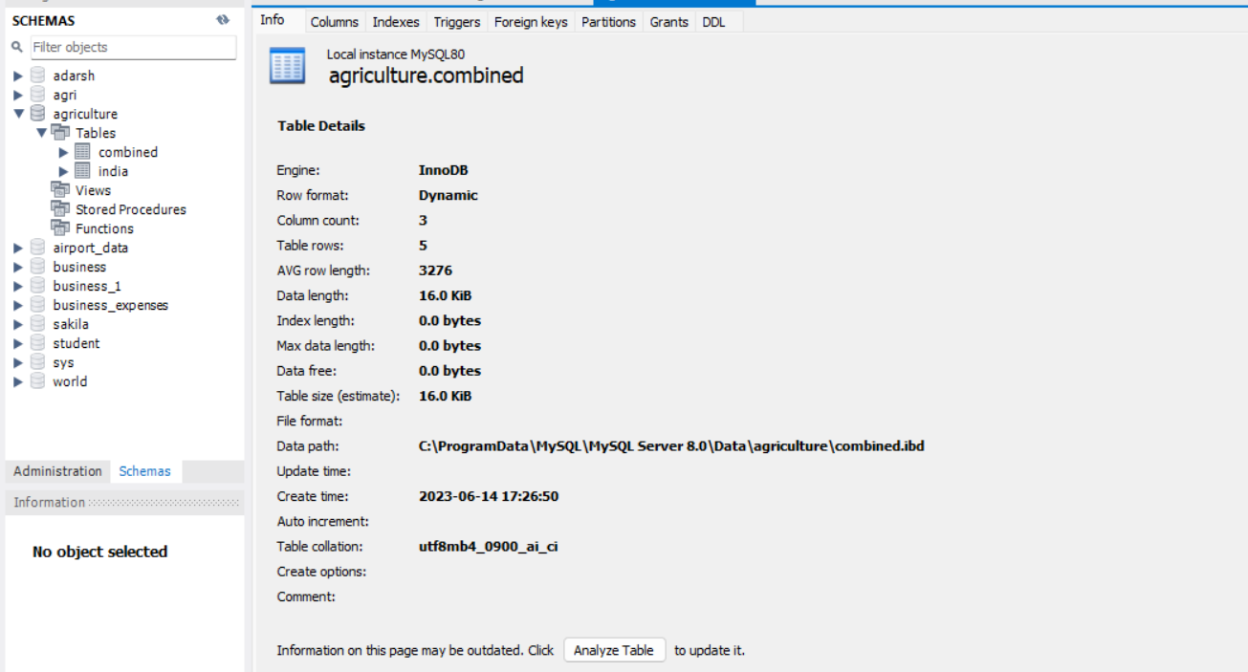

**Activity 2: Number of calculation fields**

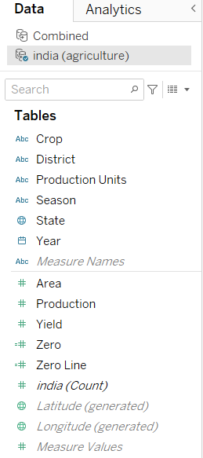

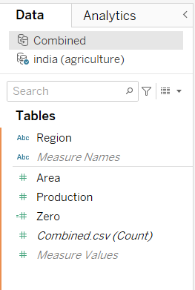

**Activity 3: Number of visualizations**

1. Statewise Agricultural Land
2. Area vs Production
3. Season based cultivation by area
4. Yield by season
5. Crop plantation by area
6. Major crops growth Yoy
7. Crops Plantation By count
8. Season wise production

**Milestone 8: Web integration**

Publishing helps us to track and monitor key performance metrics and to communicate results and progress. help a publisher stay informed, make better decisions, and communicate their performance to others.

**Activity 1: Publishing dashboard and reports to tableau public**

To publish a dashboard and report in Tableau Public, follow these steps:

1. **Create your Dashboard and Report:**
   * Build your dashboard and reports within Tableau Desktop.
   * Ensure that your data is properly connected, and your visualizations are formatted as desired.
2. **Save your Workbook:**
   * Save your Tableau workbook (.twb or .twbx file) with all the necessary data sources embedded or connected.
3. **Sign Up or Log In to Tableau Public:**
   * If you haven't already, sign up for a Tableau Public account. It's free and allows you to share your visualizations with others.
4. **Publish your Workbook:**
   * Open Tableau Desktop and go to File > Save to Tableau Public.
   * If you're already logged in to Tableau Public, your workbook will be published directly. If not, you'll be prompted to log in.
   * Follow the prompts to publish your workbook.
5. **Configure Publishing Settings:**
   * Tableau Public allows you to set various publishing options, such as whether the workbook should be visible to search engines, whether it should be downloadable, etc.
   * Choose the appropriate settings based on your preferences and the intended audience.
6. **Wait for Publishing to Complete:**
   * Depending on the size of your workbook and your internet connection speed, publishing may take some time. Tableau will notify you once the publishing process is complete.
7. **View your Published Workbook:**
   * Once published, you can view your workbook on your Tableau Public profile page.
   * You'll be provided with a unique URL for your workbook, which you can share with others to view your dashboard and reports.
8. **Share your Workbook:**
   * Share the URL of your Tableau Public workbook via email, social media, or embed it on a website for others to see and interact with.

That's it! Your dashboard and report are now published on Tableau Public and accessible to anyone with the URL.

**Activity 2: Embed dashboard and story with bootstrap**

**Creating an Admin Dashboard Interface with Bootstrap 5**:

* If you’re interested in building a simple admin dashboard, you can follow this tutorial using **Bootstrap 5**. Here are the steps:
* First, create an index.html file with the following basic markup:

**HTML**

<!DOCTYPE html>

<html lang="en">

<head>

<meta charset="UTF-8">

<meta name="viewport" content="width=device-width, initial-scale=1.0">

<title>Bootstrap 5 Simple Admin Dashboard</title>

<!-- Insert stylesheets here -->

</head>

<body>

<!-- Your dashboard content goes here -->

<h1>Hello world!</h1>

<!-- Insert scripts here -->

</body>

</html>

* Include the Bootstrap 5 stylesheet by adding the following link inside the <head> tag:

**HTML**

<link rel="stylesheet" href="https://stackpath.bootstrapcdn.com/bootstrap/5.0.0-alpha1/css/bootstrap.min.css" integrity="sha384-r4NyP46KrjDleawBgD5tp8Y7UzmLA05oM1iAEQ17CSuDqnUK2+k9luXQOfXJCJ4I" crossorigin="anonymous">

* Add the Popper.js and Bootstrap script files before the closing </body> tag:

**HTML**

<script src="https://cdn.jsdelivr.net/npm/popper.js@1.16.0/dist/umd/popper.min.js" integrity="sha384-Q6E9RHvbIyZFJoft+2mJbHaEWldlvI9IOYy5n3zV9zzTtmI3UksdQRVvoxMfooAo" crossorigin="anonymous"></script>

<script src="https://stackpath.bootstrapcdn.com/bootstrap/5.0.0-alpha1/js/bootstrap.min.js" integrity="sha384-oesi62hOLfzrys4LxRF63OJCXdXDipiYWBnvTl9Y9/TRlw5xlKIEHpNyvvDShgf/" crossorigin="anonymous"></script>

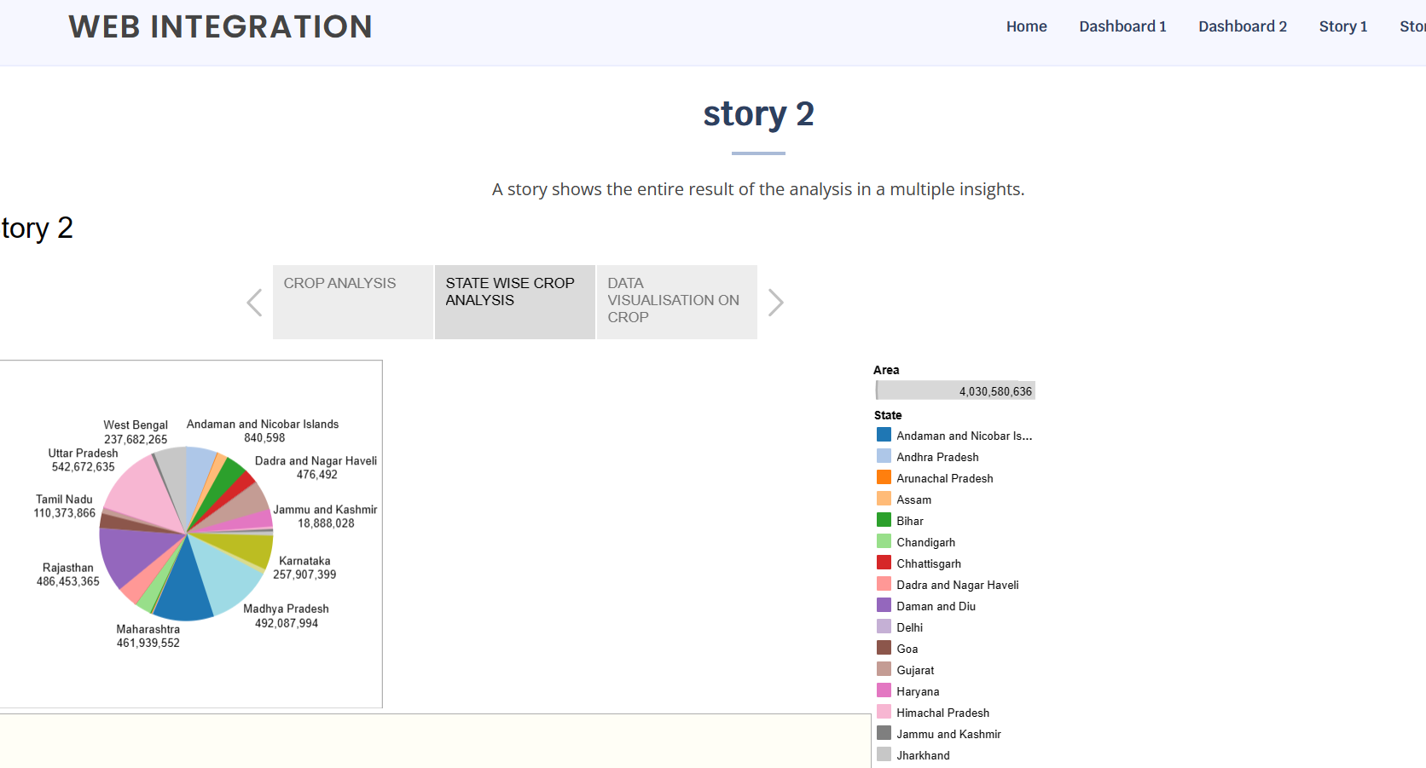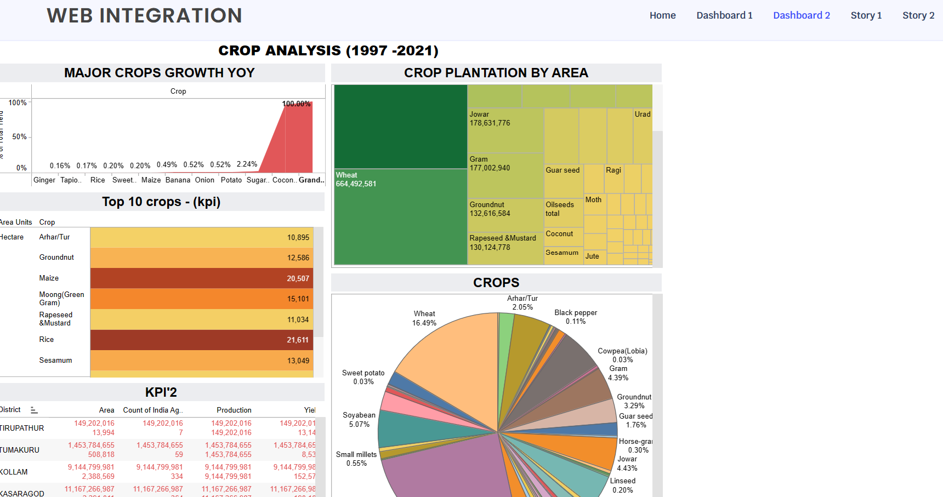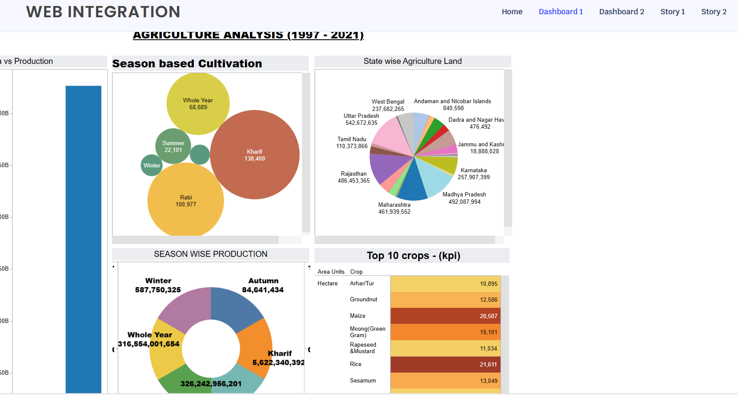

**THANK YOU……**